**TEMPERATURE MONITORING SYSTEM USING IOT**

A COURSE PROJECT REPORT

By

**Aradhya Agrahari (RA1911003010384)**

**T.Sree Rama Vijay(RA1911003010402)**

Under the guidance of

**DR. G Usha**

*In partial fulfilment for the Course*

of

18CSC302J - COMPUTER NETWORKS

in

Computer Science & Engineering



**FACULTY OF ENGINEERING AND TECHNOLOGY**

**SRM INSTITUTE OF SCIENCE AND TECHNOLOGY**

**Kattankulathur, Chengalpattu District**

NOVEMBER 2021

**SRM INSTITUTE OF SCIENCE AND TECHNOLOGY (Under Section 3 of UGC Act, 1956)**

**BONAFIDE CERTIFICATE**

It is to certify that this project report **TEMPERATURE MONITORING SYSTEM** is the bonafide work of **Aradhya** **Agrahari (RA1911003010384) and Tummalapalli Sree Rama Vijay (RA1911003010402)** who carried out the project work under my supervision.

**SIGNATURE SIGNATURE**

**Dr G Usha Dr.E. Sasikala,**

**Assistant Professor Course Coordinator**

**CSE Associate Professor,**

SRM Institute of Science and Technology **Data Science and Business Systems** Potheri, SRM Nagar, Kattankulathur, SRM Institute of Science and Technology Tamil Nadu 603203 Potheri, SRM Nagar, Kattankulathur, Tamil Nadu 603203

**ACKNOWLEDGEMENT**

We express our heartfelt thanks to our honorable **Vice Chancellor Dr. C. MUTHAMIZHCHELVAN**, for being the beacon in all our endeavors. We would like to express my warmth of gratitude to our **Registrar Dr. S. Ponnusamy**, for his encouragement. We express our profound gratitude to our **Dean (College of Engineering and Technology) Dr. T. V.Gopal**, for bringing out novelty in all executions.

We would like to express my heartfelt thanks to the Chairperson, School of Computing **Dr. Revathi Venkataraman**, for imparting confidence to complete my course project

We wish to express my sincere thanks to **Course Audit Professor Dr.M.LAKSHMI, Professor and Head, Data Science and Business Systems and Course Coordinator Dr.E. Sasikala, Associate Professor, Data Science and Business Systems** for their constant encouragement and support.

We are highly thankful to our Course project Internal guide **Dr G Usha , Assistant Professor , Computer Science and Engineering**, for **her** assistance, timely suggestion and guidance throughout the duration of this course project.

We extend our gratitude to the **Students, Dr.B.Amutha ma’am (HOD)** and my Departmental colleagues for their Support.

Finally, we thank our parents and friends near and dear ones who directly and indirectly contributed to the successful completion of our project. Above all, I thank the almighty for showering his blessings on me to complete my Course project.

**TABLE OF CONTENTS**

| **CHAPTERS** | **CONTENTS** | **PAGE**  **NO.** |
| --- | --- | --- |
| **1.** | **ABSTRACT** | 5 |
| **2.** | **INTRODUCTION** | 6 |
| **3.** | **REQUIREMENT ANALYSIS** | 7 |
| **4.** | **ARCHITECTURE & DESIGN** | 8 - 12 |
| **5.** | **IMPLEMENTATION** | 13 -19 |
| **6.** | **EXPERIMENT RESULTS & ANALYSIS**  **6.1. RESULTS**  **6.2. RESULT ANALYSIS**  **6.3. CONCLUSION & FUTURE WORK** | 20 - 21 22 - 24 25 |
| **7.** | **REFERENCES** | 26 |

**ABSTRACT**

**Measuring temperature** is one of the most common techniques used because it is important for many operations and tasks to be performed like in any industries where heaters are used, heat up to a certain temperature is required. When it comes to sensing temperature, a temperature sensor is used that is installed at a place whose temperature is to be sensed. The temperature of that place can be **monitored through the internet of things**.

Monitoring is employed in various applications,including temperature, pressure, flow rate, capacity, acceleration, and so on. According to the quantities, distribution and detected frequency of the monitored objects, there are different monitoring methods to acquire the measurements. Several problems usually occur during the monitoring process of the temperature in a room. For example, a server room must be kept between 15 to 20 degree Celsius to monitor a temperature in or else the server might crash and can cause a loss of hundreds thousands. Management has to choose either to place a person to monitor the temperature, or to save on human capital by developing a system that can monitor the temperature from other places at any given time.

**INTRODUCTION**

Heating and ventilation systems play a vital role in providing a comfortable, practical and healthy environment in our workplaces and homes. The provision of adequate heating and ventilation is becoming increasingly important in industry,homes particularly in office buildings with high employee densities. This is not only a key issue in providing work conditions that ensure employee satisfaction and hence increased productivity. Subsequently, fire, health and safety regulations are provided. In tropical area such as Nigeria, temperature control is critical in a server room, hence, air ventilation systems are usually implemented for maintaining satisfactory comfort conditions by keeping the temperature of the server within a certain range. The energy consumption as well as indoor comfort aspects of ventilated systems is highly dependent on the design, performance and control of the system and equipment . To accurately control process temperature without extensive operator involvement, a temperature control system relies upon a controller, which accepts a temperature sensor such as a thermocouple as input. It compares the actual temperature to the desired control temperature, or set point, and provides an output to a control element . Temperature control will reduce the equipment damage for computer devices as a result of excessive temperature. Due to the process of sending and receiving data there must be a transmitter and receiver to complete the task. When the temperature sensor takes the temperature of the room ,it sends the recorded value to the mcu which acts as a communication interface. From here when the recorded value is below the threshold, the heater turns on and when the temperature is above the threshold the air-conditioner or cooler turns on. The home gateway connects the temperature monitor, mobile,mcu by which we can adjust the threshold temperature for the specific room environment.

The simulation results show that smart components are connected to the home gateway and can be easily operated, monitored, and automated according to the requirements

**REQUIREMENT ANALYSIS**

**Components Required:**

**MCU :** A multipoint control unit (MCU) is a device commonly used to bridge video conferencing connections. The multipoint control unit is an endpoint on the LAN that provides the capability for three or more terminals and gateways to participate in a multipoint conference.

microcontroller (MCU) A microcontroller is a compact integrated circuit designed to govern a specific operation in an embedded system. A typical microcontroller includes a processor, memory and input/output (I/O) peripherals on a single chip.

**Temperature Sensor:** A temperature sensor is a device used to measure temperature. This can be air temperature, liquid temperature or the temperature of solid matter. There are different types of temperature sensors available and they each use different technologies and principles to take the temperature measurement.

**Air Cooling:** Air cooling is a method of dissipating [heat](https://en.wikipedia.org/wiki/Heat). It works by expanding the surface area or increasing the flow of air over the object to be cooled, or both. An example of the former is to add [cooling fins](https://en.wikipedia.org/wiki/Fin_(extended_surface)) to the surface of the object, either by making them integral or by attaching them tightly to the object's surface (to ensure efficient heat transfer). In the case of the latter, it is done by using a [fan](https://en.wikipedia.org/wiki/Fan_(mechanical)) blowing air into or onto the object one wants to cool. The addition of fins to a [heat sink](https://en.wikipedia.org/wiki/Heat_sink) increases its total surface area, resulting in greater cooling effectiveness.

**Dlc Home Gateway:**

The cisco packet tracer interface provides inbuilt devices to be added in the network. The first step is to select a home gateway device from the network devices. To authenticate and validate the wireless connection, we also can configure the home gateway with WEP/WPA-PSK /WPA2 protocols.

**3.1 Hardware Requirements**

Processor : 2.4 / 5 GHz Clock Speed RAM : 2 GB

Hard Disk : 100 MB (Minimum free space)

**3.2 Software Requirements**

Operating System : Windows 7 and above Language : java script

Local Platform : Cisco packet tracer

Data Storage : Downloads,Saved files

**ARCHITECTURE AND DESIGN**

This system contains hardware and software components. The hardware components are Temperature Sensor, AC, Heater, Temperature Monitor,MCU .

The software components include SmartPhone or Laptop. Temperature sensor monitors the temperature and sends the data to MCU, it processes that data and if the temperature is low or high it turns on the heater and AC respectively.

The user can view the temperature via his phone or laptop anytime. MCU works on turning on/off of AC and heater alternatively and maintains the temperature in the given threshold range.MCU is programmed such that it on/off AC/Heater automatically.

**FUNCTIONAL REQUIREMENTS:**

➢ User should enter correct passkey to connect to the home gateway.

➢ User should be able to enter the threshold temperature through his device.

➢ The user should be able to view the status of temperature of the place .

➢ AC and Heater should turn on/off automatically.

**NON - FUNCTIONAL REQUIREMENTS:**

➢MCU turn on/off AC and Heater respective to the current temperature.

➢ Security.

➢ User should be able to work on the system easily.

➢ User gets notification when temperature is deviated largely from threshold range and AC/Heater do not turn on/off.

**Architecture Diagram :**

A simple architecture diagram (UML) helps system designers and developers visualize the high-level structure of their system or application to ensure it meets their users' needs. It can also help describe patterns that are used throughout the design.

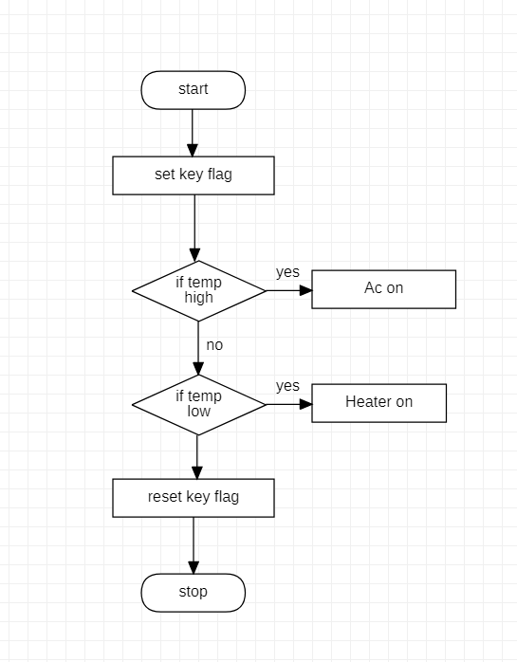

**Architecture diagram for temperature monitoring system**

**IMPLEMENTATION**

The temperature monitor starts displaying the temperature with code and by using some components

* MCU (MICRO CONTROLLER UNIT)
* TEMPERATURE SENSOR
* AIR COOLER
* HEATING ELEMENT
* TEMPERATURE MONITOR
* DLC HOME GATEWAY
* TABLET/PC

**MCU:**

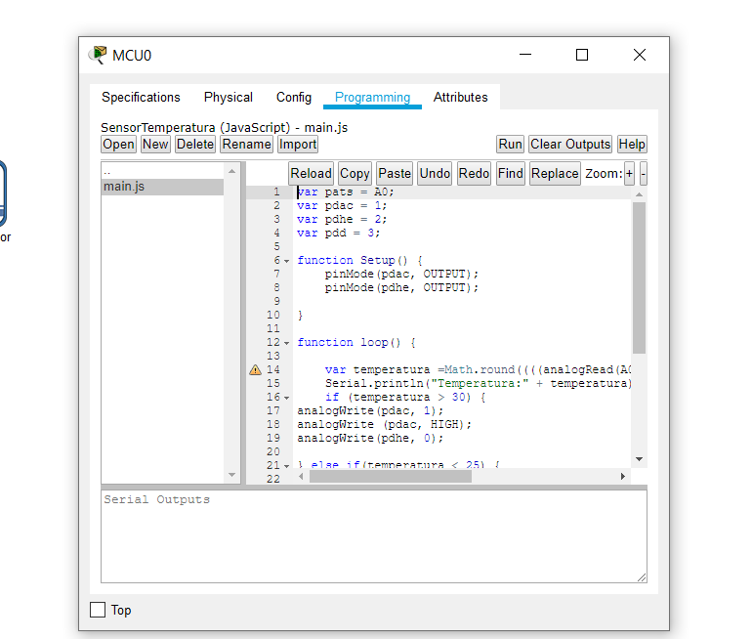

In mcu we write the code in javascript language for temperature monitoring weather if temperature rises automatically ac on or if temperature is low it automatically switch on heater

**TEMPERATURE SENSOR**:

It is used to operate temperature to -100 degrees celsius to 100 degrees celsius

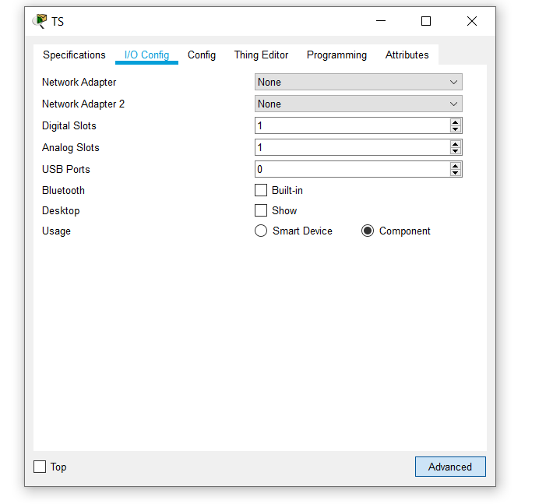

**AIR COOLER**:

It cools the room if temperature is greater than 30 degrees

And we given the display name as AI and serial number PTT0810ME33-

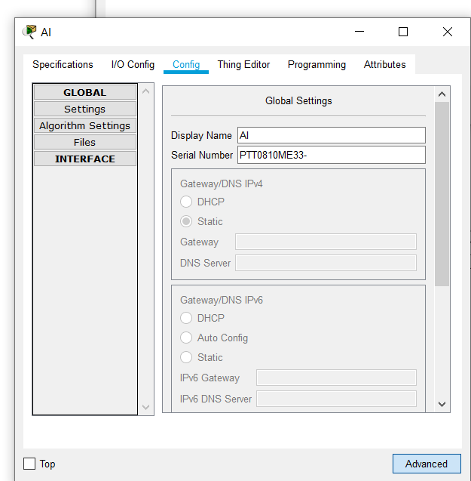

**HEATING ELEMENT** :

If the temperature is less than 25 degrees it automatically switches on heater

Here the display name is He

Serial number is PTT0810L75V-

**Temperature Monitor** :

It records the temperature of the room

Display name IOT 3

Serial number PTT08108149-

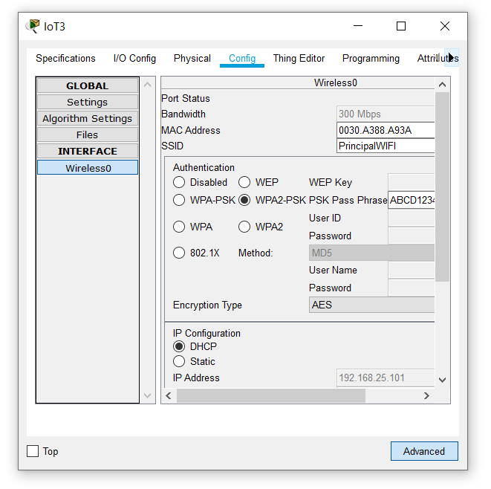

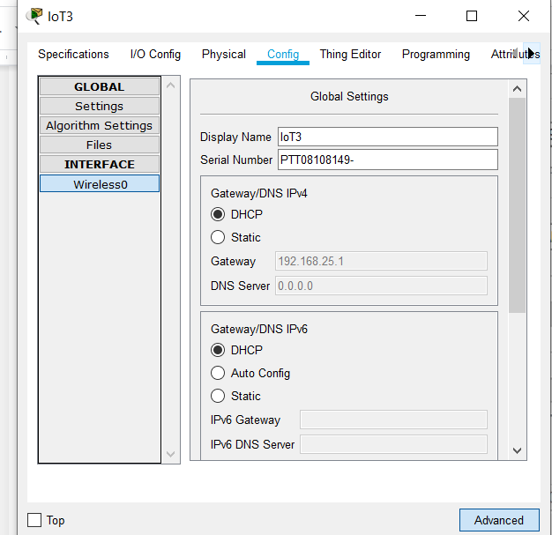

**DLC HOME GATEWAY** :

The Home Gateway provides 4 ethernet ports as well as a wireless access point configured with the "HomeGateway" ssid on channel 6. WEP / WPA-PSK / WPA2 enterprise can be configured to secure wireless connections. The picture below shows 4 IOE Things attached to a Home Gateway The Home Gateway is connected to the Internet through it's Internet WAN ethernet port.

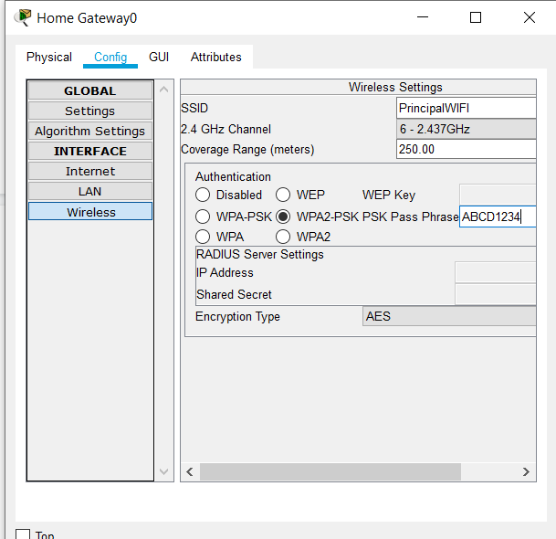

**TABLET/PC** :

It displays the temperature in tablet

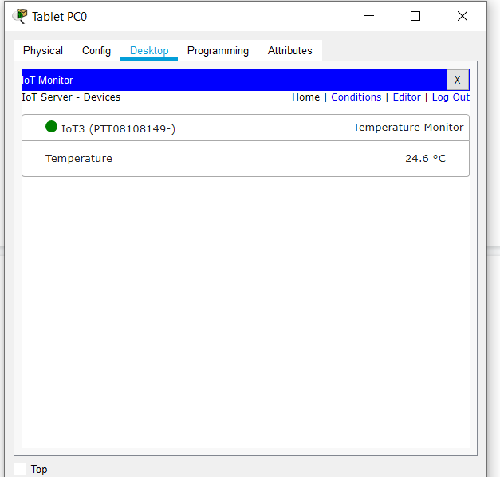

**EXPERIMENT RESULTS & ANALYSIS**

**6.1. RESULTS**

The Results of the room temperature monitoring system is shown using CISCO packet tracer. The project is done according to the requirement. All the devices are monitored through smartphones.when the room temperature is below the given threshold temperature the heater will turn on and increase the temperature until it reaches the specified range.Similarly when the temperature is above the given threshold the air cooler will turn on until it reaches the specified given range.

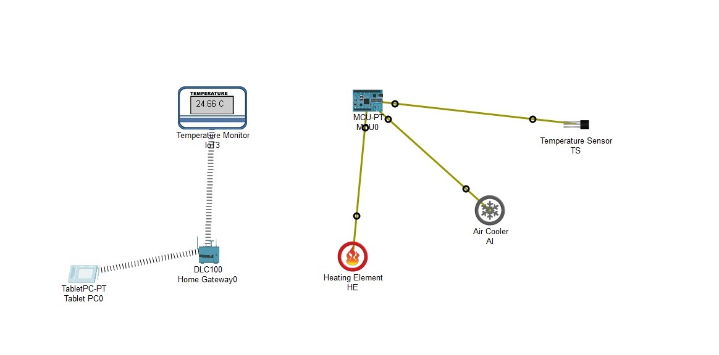

Here the room temperature is 24.6 C as pr the temperature monitor.

The room temperature is below the threshold temperature given that is in range (25-30). Here the mcu takes over control and turns on the heater until it reaches the range given.

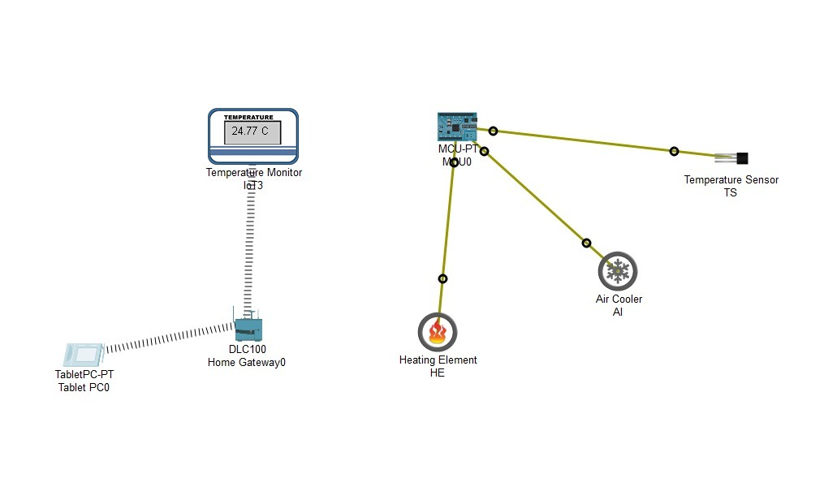

Here the value of the room temperature is increased as we can see the simulation in the cisco. The temperature increases upto 25 C ie, upto range given.

Similarly the same thing occurs for the cooler when the temperature is above the range.

**6.2. RESULT ANALYSIS**

| TEST ID | Expected Results | Actual Results | Status |
| --- | --- | --- | --- |
| T1 | The temperature should collect temperature data without any errors and send it to MCU. | MCU accepts the data. | Pass |
| T2 | Programming done in MCU should run without any errors. | Program runs without any errors. | Pass |
| T3 | MCU should turn on/off AC and heater automatically. | AC and heater turn on/off automatically. | Pass |
| T4 | Temperature monitor should take the current temperature and send it to the user device. | Correct temperature is sent to the user device. | Pass |
| T5 | Mobile phones should display the status of temperature to the user. | User can view the status in his device. | Pass |
| T6 | Threshold range should be maintained all the time. | Temperature is in the given range all the time. | Pass |

**CONCLUSION & FUTURE WORK**

A Temperature monitoring system is implemented using the Cisco packet tracer. A home gateway to register the devices and control them using a tablet. All the IoT devices connected to the home gateway can be monitored manually as well as remotely by the user. The results prove that there is an opportunity of applying this model in real life. The implementation of the Temperature monitoring system can be used to reduce the use of electricity and human effort.

Embracing new technologies is essential in the development, modernization.The Internet Of Things is playing a major role in the development of more advanced and efficient systems in different sectors. The monitoring system which we developed enables the household,server rooms and different room environments to maintain a specific range of temperature. This way the owner can manage the working environment temperature without the need of on/off AC/Heater manually. The system also automatically controls itself there by maintaining the temperature of the room.

This simple implementation of the Internet of Things in monitoring is just an example of how powerful the IoT technology is.

When the system is manually monitored it increases the human need which leads to loss of money but by this the efforts and time can b consumed.

In the field of IoT, ensuring security should be a priority. Since the IoT devices are interconnected to each other, the network should be secured. In this system, an authentication gateway is designed that requires a password to check the authenticity of the home user for security purposes.

**Future Work :**

Increase the scale of the project so that it can be used in large area rooms,industry,Factory e.t.c.,

To extend this system to be more robust and efficient in the future, modifications can be made to make the system more secure. If abnormalities in the system are detected, the system should send an SMS or an Email to alert the user.

**REFERENCES**

[1]Tavares, J., Velez, F.J., Ferro, J.M., “Application of wireless sensor networks to automobiles,” Measurement Science Review, Vol. 8, Section 3, pp: 65-70, 2008.

[2] “ZigBee Home Automation Public Application Profile”, ZigBee Alliance,Rev 25, Ver 1.0, 2007.

[3] Yu, Y., Prasanna, V.K., Krishnamachari, B., “Information Processing andRouting in Wireless Sensor Networks,” World Scientific Publishing Co.,2006.

[4] “Zigbee Sensor Tag Data Sheet”, Pultronics Inc.

[5] George W. Irwin, Jeremy Colandairaj and William G. Scanlon, “AnOverview of Wireless Networks in Control and Monitoring,”International Conference on Intelligent Computing (CHINE 2006), Vol.4114, pp. 1061-1072, 2006.

[6] Cai Bin, Jin Xinchao, Yan Shaomin; Yang Jianxu; Zhao Xibin; ZouGuowei; “ Application research on temperature WSN nodes in switchgear assemblies based on TinyOS and ZigBee,” 4th International Conferenceon Electric Utility Deregulation and Restructuring and PowerTechnologies (DRPT), 201, pp: 535 – 538, 2011

[7] G. Virone, A. Wood, L. Selavo, Q. Cao, L. Fang, T. Doan, Z. He, R.Stoleru, S. Lin, and J. A. Stankovic, “An Advanced Wireless SensorNetwork for Health Monitoring,” Transdisciplinary Conference onDistributed Diagnosis and Home Healthcare (D2H2), April 2-4, 2006